Made In the Shade
The Pompano Beach Badcock Furniture store serves a racially, culturally, and economically diverse community. Some here would consider themselves lucky to have a comfortable and well-made sofa from Badcock each night while others take leisurely afternoons naps on their well-built and comfortable sofas. Or at least they would if they had one. They have yet to be enlightened.
Some of the people here would consider a home with a roof and four walls a mansion instead of the huts to which they are accustomed and a sofa so desirable beyond imagination. Others come from, or are descendants of those who came from, an island nation where vintage American automobiles are a way of life. An expectation of reliability, quality, and price are inherent in their search for prosperity.
The Plantation area is a beach-front community with lovely beaches and some lovely people and continues to experience change but it is not presently the crown jewel of Metropolitan Miami. There are others areas where there are mega-mansions and beaches where all the trash is picked up instead of being left to litter the beach if that is what one wants. People who live here are real beach lovers but those unlikely to draw attention from the Internal Revenue Service for significant tax evasion.
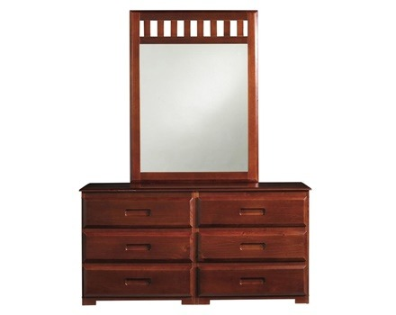
Furniture store options here are as diverse as the demographics. Attractiveness, utility, and reliability are the most frequent motivators for buyers here and Badcock has stepped up to the plate to meet those diverse needs. For those unwilling to pay the price of a good used car for a sofa the Pompano Beach furniture retailer can help the customer find living room furniture that will still be standing in six months and will have long since been paid for in six years.
Our area does boast some restaurants and tourism but the majority of those are found in surrounding communities. Here furniture is not bought, amortized, and then replaced as in some of the more high-profile and glitzy metro touristy communities. While the citizens here may not keep the furniture as long as many of the islander Cubans have kept dated American cars, the objective is something useful and attractive that would not be expected to collapse or grow thread bare before the next presidential election. We can meet the needs of those customers too.
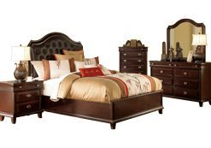
And most certainly the more prosperous dwellers of our community our store is also able to please. For those able, and willing, to dress their living rooms to impress, attractive, stunning, inviting, and compelling pieces await their permanent homes in the community. And they may not have to empty the king’s treasury of their castles to finance their indulgences.
Do keep in mind other factors when considering living room furniture. Pompano Beach is a community near the ocean with times of the year where a sealed, air-conditioned unit may not always be the norm. Under such circumstances glass and chrome may be beautiful and glow with contemporary proclamations, they, along with metal furniture, will invariably succumb to the influences of salt air.
Leather furniture, too, may be built like a bronco and as cozy as a bear cub but how does the sand in the atmosphere combine with the leather surfaces against human skin? No one is saying to not. Only to think about the purchase one considers.
Badcock Furniture in South Florida’s Plantation and Pompano Beach areas has payment plans as diverse as the styles of furniture available in our stores and as varied as the types of customers we serve. For the aggressive payer, we offer six, 12, and 18-month plans with no interest charges if the purchase price is paid within the term. A minimum purchase amount will likely apply. But we do report to the credit reporting agencies consistently for those looking to establish or reestablish credit references.
For the methodical and budget-conscious payer we offer a 12-month plan with a minimal monthly payment and a purchase limit but it does not require a credit check and consistent reports to credit reporting agencies are made. Come see what Badcock can do for you.

